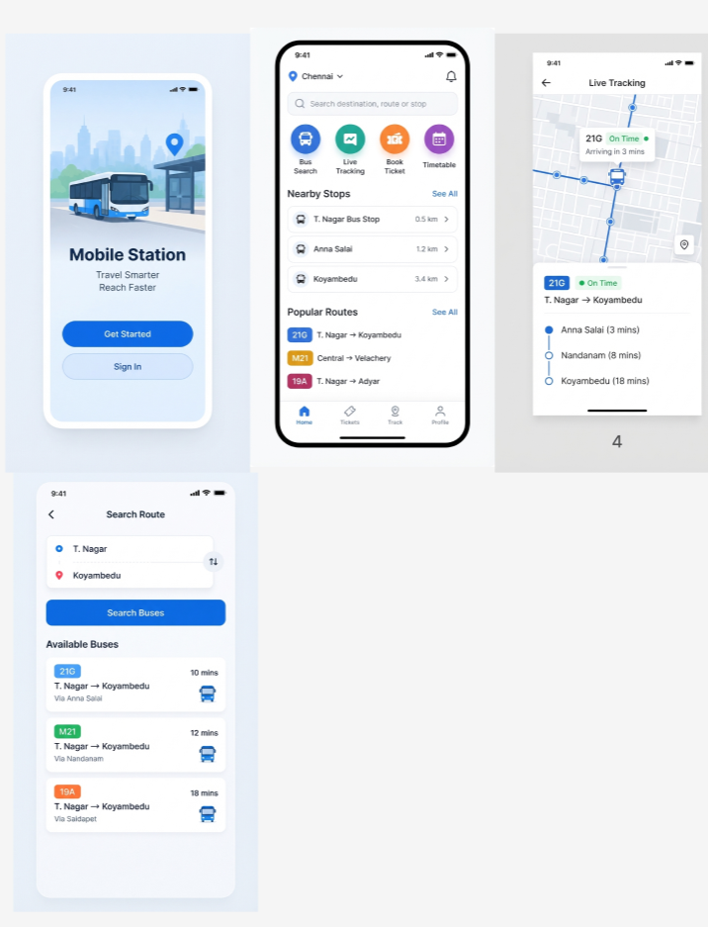
1.Design a user interface prototype for a mobile station using Figma, considering connectivity and convenience.
2.Use Figma to create an interactive diagram illustrating the components of a basic cellular System
